Objective: To understand the practical application of subschemas for security and access control. Outcome: define appropriate subschemas for different user roles. Steps: Using the library schema from the previous activity, the instructor defines user roles: 'Librarian', 'Member', and 'Auditor'. Define what data their assigned role should be able to see and modify. Create a simple UML diagram or a list representing their subschema. For example, the 'Member' group might decide their subschema only includes access to view the Books table and their own Loans .Determine the minimal data access required for them to perform their duties.
Below is a clear, classroom-ready solution showing how subschemas support security and access control using the library database.

1. Reminder: What Is a Subschema?
A subschema is a user-specific view of the database:
- Shows only the data a role needs
- Restricts what can be viewed or modified
- Improves security, privacy, and simplicity
Think of it as “each user sees their own version of the database.”

2. User Roles Defined
- Librarian → Manages books and loans
- Member → Borrows books and views own activity
- Auditor → Reviews records, no changes allowed

3. Subschema Definitions by Role
A. Librarian Subschema
Purpose: Operate and manage the library system
Tables Accessible
- Book
- Member
- Loan
Permissions
- View: All records
- Insert: New books, members, loans
- Update: Book details, member info, loan return dates
- Delete: Incorrect or obsolete records (policy-based)
Minimal Data Needed
- Full access is justified because librarians perform all operational tasks
Subschema (List Representation)
Librarian Subschema
- Book (ALL attributes)
- Member (ALL attributes)
- Loan (ALL attributes)
Permissions: SELECT, INSERT, UPDATE, DELETE

B. Member Subschema
Purpose: Browse books and track personal loans
Tables Accessible
- Book
- Loan (restricted)
Permissions
- View:
  - All books
  - Only their own loans
- Modify: None (or possibly renew requests via application logic)
Restrictions
- Cannot see:
  - Other members
  - Other members’ loans
  - Internal data like CopiesAvailable logic
Minimal Data Needed
- Book details to choose books
- Loan dates to track borrowings
Subschema (List Representation)
Member Subschema
- Book (ISBN, Title, Author, Publisher, PublicationYear)
- Loan (LoanDate, DueDate, ReturnDate)
Condition: Loan.MemberID = LoggedInMemberID
Permissions: SELECT only

C. Auditor Subschema
Purpose: Verify accuracy and compliance
Tables Accessible
- Book
- Member
- Loan
Permissions
- View only
- No insert, update, or delete
Restrictions
- Cannot change data
- May have sensitive fields masked (e.g., phone, address)
Minimal Data Needed
- Complete historical data for verification
- No operational access
Subschema (List Representation)
Auditor Subschema
- Book (ALL attributes)
- Member (MemberID, Name, MembershipDate)
- Loan (ALL attributes)
Permissions: SELECT only

4. Simple UML-Style View (Textual)
+----------------+
| Librarian |
|----------------|
| Book (CRUD) |
| Member (CRUD) |
| Loan (CRUD) |
+----------------+

+----------------+
| Member |
|----------------|
| Book (Read) |
| Loan (Read-own)|
+----------------+

+----------------+
| Auditor |
|----------------|
| Book (Read) |
| Member (Read) |
| Loan (Read) |
+----------------+

5. Key Learning Takeaways for Students
- Subschemas enforce least privilege
- Different users see different database views
- Subschemas:
  - Improve security
  - Protect privacy
  - Reduce user complexity

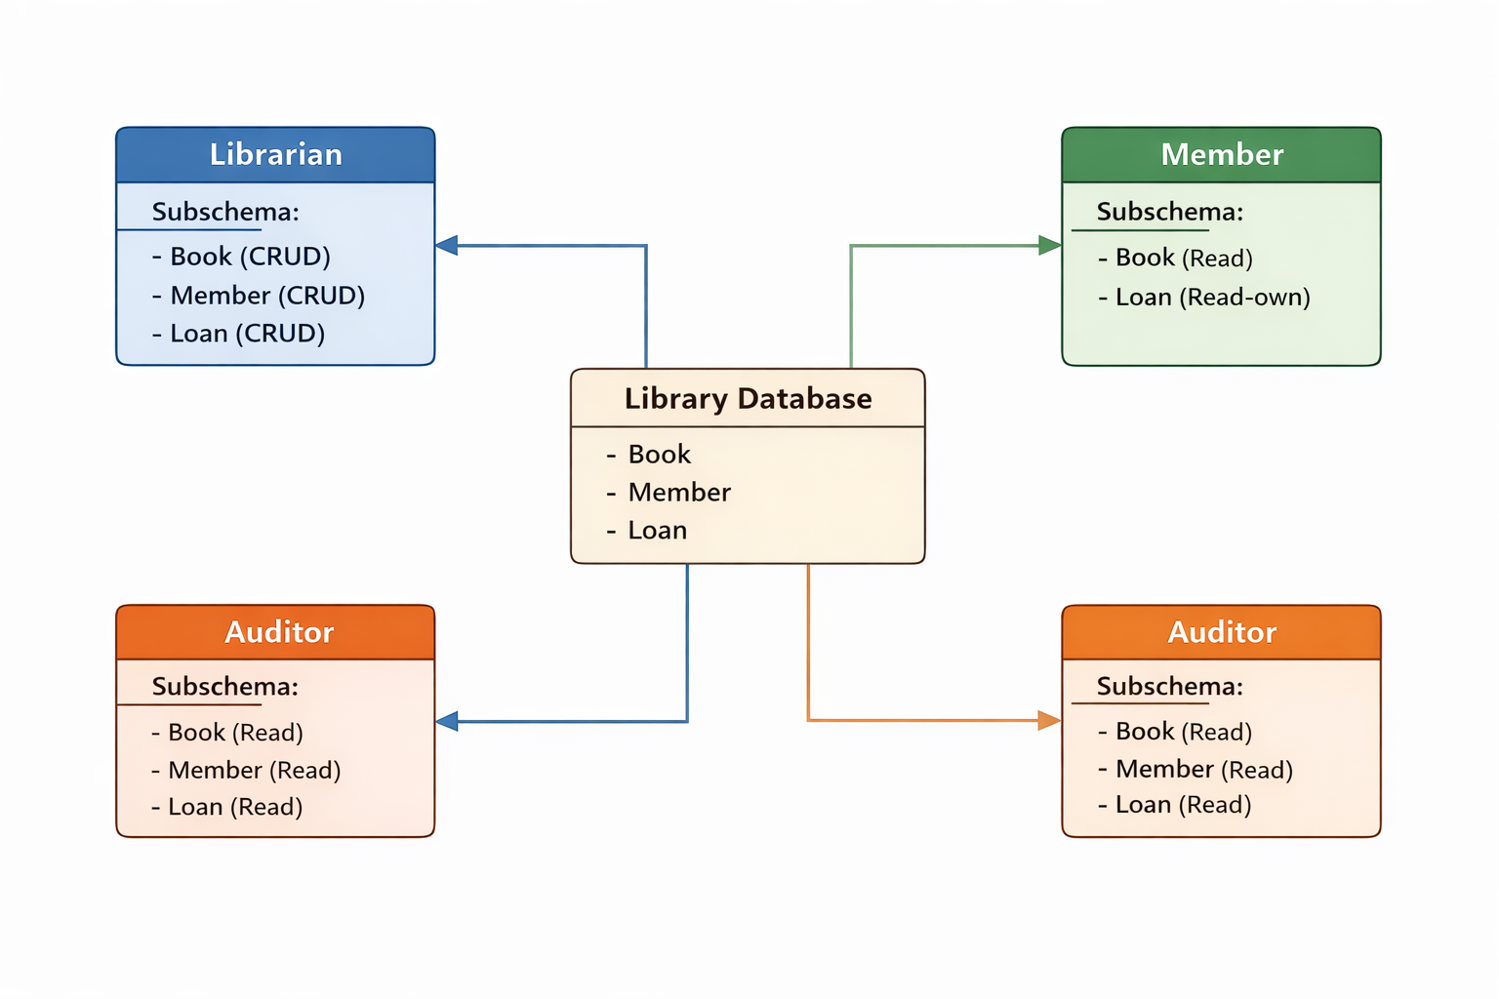

CRUD is an acronym that describes the four basic operations you can perform on data in a database.

CRUD Explained
Letter | Meaning | What it allows a user to do
C | Create | Add new records (e.g., add a new book or member)
R | Read | View or retrieve data (e.g., see book details)
U | Update | Modify existing records (e.g., update book info or mark a loan as returned)
D | Delete | Remove records (e.g., delete an incorrect loan entry)

CRUD in the UML Diagram Context
- Book (CRUD) → The role can create, view, update, and delete book records
- Loan (Read-own) → The role can only view their own loan records
- Book (Read) → The role can only view book information

Simple Student-Friendly Explanation
CRUD describes everything you can do to data: add it, see it, change it, or remove it.

Why CRUD Matters for Subschemas
Using CRUD helps clearly define:
- Who can do what
- Which data is protected
- How access is limited by role
If you’d like, I can also map CRUD directly to SQL commands (INSERT, SELECT, UPDATE, DELETE) for teaching purposes.
yes
Great — here is a clear mapping of CRUD operations to SQL commands, tied directly to the library subschemas you’ve been using.

1. CRUD ↔ SQL Command Mapping
CRUD | Meaning | SQL Command | Example
C | Create | INSERT | Add a new book
R | Read | SELECT | View available books
U | Update | UPDATE | Mark a book as returned
D | Delete | DELETE | Remove a loan record

2. CRUD + SQL by User Role

A. Librarian (Full CRUD)
Permissions: INSERT, SELECT, UPDATE, DELETE
-- Create a new book
INSERT INTO Book (ISBN, Title, Author, Publisher, PublicationYear, CopiesAvailable)
VALUES ('9781234567890', 'Database Systems', 'Elmasri', 'Pearson', 2022, 5);

-- Read all loans
SELECT * FROM Loan;

-- Update book copies
UPDATE Book
SET CopiesAvailable = CopiesAvailable - 1
WHERE BookID = 10;

-- Delete an incorrect loan record
DELETE FROM Loan
WHERE LoanID = 45;

B. Member (Read-Only, Own Data)
Permissions: SELECT only (restricted)
-- View all books
SELECT Title, Author, PublicationYear
FROM Book;

-- View own loans only
SELECT LoanDate, DueDate, ReturnDate
FROM Loan
WHERE MemberID = :LoggedInMemberID;
🔒 Note: The WHERE MemberID = :LoggedInMemberID enforces subschema-level security.

C. Auditor (Read-Only, All Data)
Permissions: SELECT only
-- Review book records
SELECT * FROM Book;

-- Review member list (limited fields)
SELECT MemberID, FirstName, LastName, MembershipDate
FROM Member;

-- Review all loan transactions
SELECT * FROM Loan;

3. How Subschemas Are Implemented in Practice
Option 1: SQL Views (Most Common)
CREATE VIEW Member_Loans_View AS
SELECT LoanDate, DueDate, ReturnDate
FROM Loan
WHERE MemberID = CURRENT_USER;
Members only see their own loans, even though the full table exists.

Option 2: Role-Based Privileges
GRANT SELECT ON Book TO MemberRole;
GRANT SELECT ON Loan TO MemberRole;

GRANT SELECT, INSERT, UPDATE, DELETE ON Book TO LibrarianRole;

4. Key Teaching Takeaways for Students
- CRUD describes actions
- SQL enforces those actions
- Subschemas = controlled views + permissions
- Security is built into the database design, not just the application

Primary purpose: security and role based access

Tables in the full schema
-Books
-Members
-Loans

Role1: Librarian Subschema
Librarian - Allowed Data Access

Table View Insert Update Delete

Books Y Y Y Y
Members Y Y Y N
Loans Y Y Y N

Notes:
-Can see all columns
-can update return_date when a book is returned
-Cannot delete loan history (audit trail)

LIBRARIAN
- Books (all columns, full access)
- Members (all columns, no delete)
- Loans (all columns, no delete)

Role2 : Member Subschema

- Books (read-only)
- Loans (read-only, filtered by member_id)

Role3: Auditor Subschema

-Books(read-only)
-Members(read-only, limited columns)
-Loans(read-only)

UML

FULL SCHEMA
|
|-Librarian Subschema
| - Books
| - Members
| - Loans
|
|- Member Subschema
| - Books (view)
| - Loans (own only)
|
|- Auditor Subschema
- Books (view)
- Members (view)
- Loans (view)

